Technical note Date: 2016.06.27
Speed log SKIPPER EML224. SAM4642
AC/DC converter in electronic unit JB60N2-SA, JB60N2-LA and JB60CD-SA
SKIPPER Electronics has registered a higher number of faults in the Electronic unit. The fault is located in the power supply part. 24V to sensor and communication with display unit will stop.
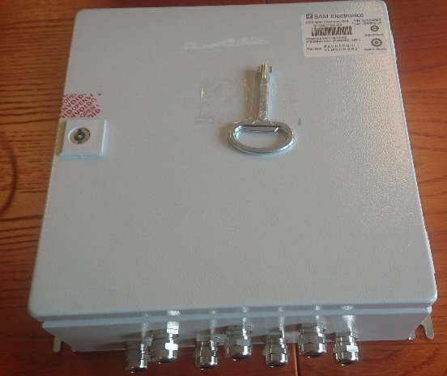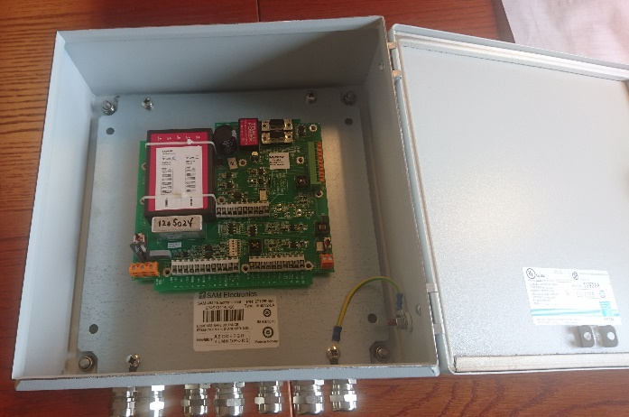
The fault occurs only on units power with 115/230V AC power.
The JB60 Electronic unit may be powered from 24VDC or 115/230VAC. Units with faulty AC-DC converter will work if powered by 24VDC.
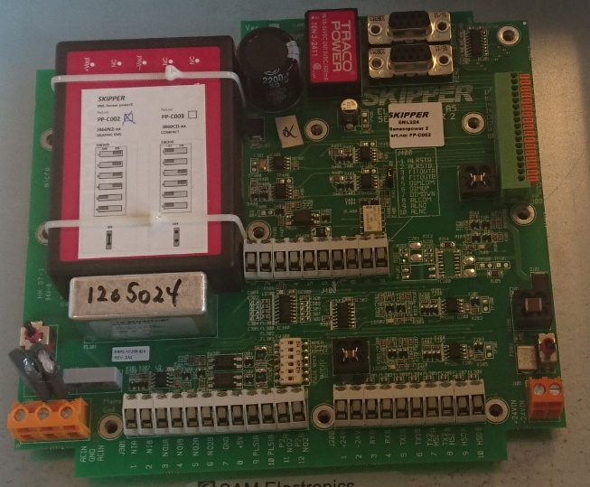
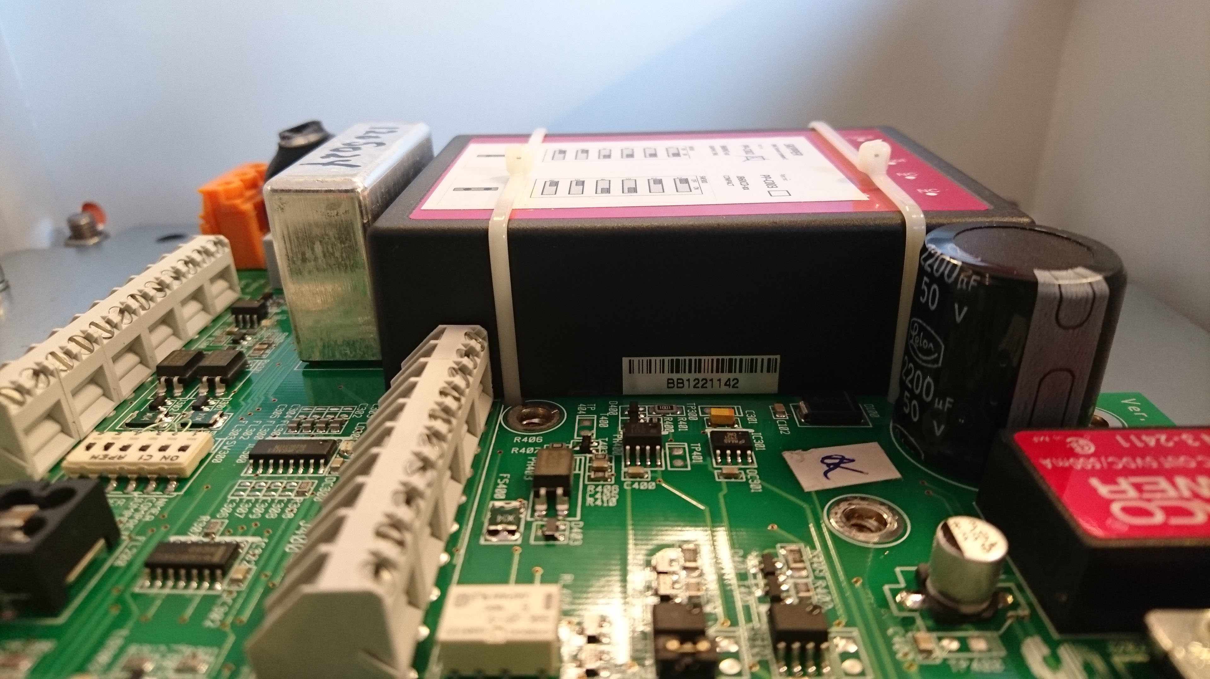
Batch number label
AC/DC Converter
115/230VAC Power input
24VDC Power input
The faulty AC/DC Converters have
batch numbers starting at BB.
The batch with suspected faults have been
used in JB60 electronic units from 2012 to 2015.
SKIPPER has decided to extend the warranty on this type of fault to 5 years from shipment.
Any working units found with this batch number SKIPPER will offer to replace the AC/DC converter the PCB if returned to SKIPPER.

